**“DEFORESTATION MAPPING USING SATELLITE IMAGES AND DEEP LEARNING TECHNIQUES.”**

**MINI PROJECT REPORT**

Submitted in partial fulfillment of the requirements for the award of the degree of

**BACHELOR OF TECHNOLOGY**

**IN**

**COMPUTER SCIENCE & ENGINEERING**

**(Artificial Intelligence & Machine Learning)**

**BY**

KESHAV (2220804)

SHOURYA KHANKA (2100852)

ANKITA KOTNALA (2220802)

ARNAV SIRKHAL (2100863)

## Under the guidance of

Dr. RASHMI SAINI

(Associate Professor)

Department Of Computer Science & Engineering

**G.B. Pant Institute of Engineering & Technology**

**Pauri Garhwal, Uttarakhand Session 2023-2024**

# CANDIDATE DECLARATION

We as a result of this declare that the project work entitled **“Deforestation Mapping using Satellite Images and Deep Learning techniques.”** in partial fulfillment of the requirements for the award of the Degree of **BACHELOR OF TECHNOLOGY in COMPUTER SCIENCE AND ENGINEERING with specialization in ARTIFICIAL INTELLIGENCE & MACHINE LEARNING** submitted to the Department of Computer Science & Engineering, G.B. Pant Institute of Engineering & Technology, Pauri, Uttarakhand, is an authentic record of our work carried out during a period from February 2024 to June 2024 under the supervision of Dr. Rashmi Saini, Associate Professor, Department of Computer Science and Engineering.

We have not submitted the matter presented in this project for the award of any other degree of this or any other university.

|  |  |
| --- | --- |
| **Student Name** | **College Id** |
| Keshav 2220804  Shourya Khanka 2100852  Arnav Sirkhal 2100863  Ankita Kotnala 2220802 | |

This is to certify that the above statement made by the candidate is correct to the best of my knowledge.

Date: 07/06/2024 Dr. Rashmi Saini

(Project Supervisor)

### 

### Dr. Ashish Negi

Head Of Department

Computer Science & Engine G.B. Pant Institute of Engineering & Technology, Pauri Garhwal

(Uttarakhand)

### Mrs. Meenakshi Kathayat

Project Cordinator

Computer Science & Engine G.B. Pant Institute of Engineering & Technology, Pauri Garhwal

(Uttarakhand)

# ACKNOWLEDGMENT

We wish to express our deep gratitude to our guide Dr. Rashmi Saini for all the advice, encouragement, and constant support he has given us throughout our project work. This work would not have been possible without his support and valuable suggestions.

We sincerely thank our respected Project Coordinator of the department, Mrs. Meenakshi Kathayat, Assistant Professor, Department of Computer Science & Engineering, for her great support in coordinating project schedules, providing resource equipment and information, and liaising with group members to define project requirements, scope, and objectives.

We are also grateful to Dr. Ashish Negi, Head of the Department of Computer Science & Engineering, for providing us with the necessary facilities to complete our project work.

We would like to thank all our friends for their help and constructive criticism during our project work. Finally, we have no words to express our sincere gratitude to our parents, who have shown us this world and provided us with every support.

|  |  |
| --- | --- |
| **Student Name** | **College Id** |
| Keshav 2220804  Shourya Khanka 2100852  Arnav Sirkhal 2100863  Ankita Kotnala 2220802 | |

# ABSTRACT

Deforestation threatens global ecosystems, biodiversity, and climate stability. Traditional monitoring methods are labor-intensive and limited. This project leverages satellite imagery and deep learning for efficient deforestation analysis. Using multi-temporal satellite images, the project captures dynamic changes in forest cover. The process includes data preprocessing, model training, utilizing imagery from Sentinel datasets.

A deep learning model distinguishes between forested and non-forested areas and identifies land cover changes indicating deforestation. It also highlights at-risk regions, facilitating proactive conservation and policy interventions. Results show that integrating satellite imagery with deep learning is effective for deforestation monitoring, offering high accuracy, scalability, and timeliness.

The project supports early detection and comprehensive analysis of deforestation trends, aiding in forest preservation and climate change mitigation. It demonstrates the potential of combining satellite technology with deep learning to enhance environmental monitoring, sustainable forest management, and the protection of natural resources for future generations.

**TABLE OF CONTENTS**

**S.No Contents Page.**

1. **INTRODUCTION 2**
2. **OBJECTIVES 3**
3. **LITERATURE REVIEW 4**
4. **RELATED WORKS………………………………………..…...11**
5. **FEASIBILITY STUDY 12**
6. **METHODOLOGY 13**
7. **SYSTEM REQUIREMENTS………………………………..…15**
8. **FLOWCHART……………………………………………..……18**
9. **SYSTEM ARCHITECTURE OVERVIEW………..………….19**
10. **SENTINEL 2 IMAGES…………………………………...…….21**
11. **MLC OUTPUT………………………………………..…………22**
12. **FUTURE ENHANCEMENTS………………………………….23**
13. **EXPECTED OUTCOMES………………………………...……24**
14. **CONCLUSION…………………………………………………..25**
15. **REFERENCES……………………………………………...…...26**

**INTRODUCTION**

Deforestation is a critical environmental issue that significantly impacts biodiversity, climate change, and human livelihoods. Accurate mapping and monitoring of deforestation are essential for effective forest management and conservation strategies. This project aims to develop a comprehensive deforestation mapping approach focusing on Dehradun, a district in India known for its rich forest cover. The primary objective is to analyze changes in forest cover over a five-year period, from 2015 to 2020, using remote sensing and advanced geospatial techniques.

Our project began with selecting Dehradun as the study area due to its ecological significance and the availability of high-quality remote sensing data. The initial step involved downloading the India map and extracting the Dehradun shapefile using ArcGIS software. This shapefile was then uploaded to the Copernicus Open Access Hub to acquire Sentinel-2 satellite imagery for the months of October to December 2015, covering the entire Dehradun district across three tiles.

The downloaded Sentinel-2 data, specifically the MSI files, were processed using the SNAP software for atmospheric correction to ensure accuracy and consistency in the satellite imagery. Subsequently, these corrected images were imported into ArcGIS software for further analysis. We composited bands 2, 3, 4, and 8, which have a 10-meter resolution, to create a detailed and high-resolution image of the study area. These composite images were then mosaicked to combine the three tiles into a single seamless tile.

Using the Dehradun shapefile, we performed masking on this mosaicked tile to extract the area of interest, resulting in a raster file in .tif format. For the classification of land cover types, we employed both unsupervised and supervised classification methods. Initially, we used ISODATA clustering and K-means algorithms in Python and ArcGIS to perform unsupervised classification. Subsequently, training data were created and used to implement the Random Forest algorithm and Maximum Likelihood Classification (MLC) for supervised classification.

The classified output included six distinct classes: Evergreen Forest, Deciduous Forest, Cropland, Fallow Land, Water Bodies, and Developed Area. This classification provided a detailed land cover map for Dehradun for the year 2015. In the next phase of the project, we will replicate this process for Sentinel-2 data from October to December 2020. This will allow us to compare the datasets and observe changes in land cover over the five-year period.

The subsequent sections of this report will present the detailed methodology, results, and analysis for each classification technique, with a focus on the 2015 data. The upcoming semester will involve similar processing of the 2020 data to map deforestation trends and changes in Dehradun's land cover. This project not only highlights the importance of remote sensing in environmental monitoring but also provides valuable insights for forest conservation and management in the region.

**OBJECTIVES**

The primary objective of this project is to develop a comprehensive approach to mapping deforestation in the Dehradun district using remote sensing and advanced geospatial techniques. The specific objectives are as follows:

1. **Selection of Study Area**:
   * Identify and select Dehradun district as the focal area for deforestation mapping due to its ecological significance and availability of relevant data.
2. **Data Acquisition**:
   * Download and extract the Dehradun shapefile from the India map using ArcGIS software.
   * Acquire Sentinel-2 satellite imagery for the months of October to December 2015 and 2020 from the Copernicus Open Access Hub, covering the entire Dehradun district.
3. **Data Preprocessing**:
   * Perform atmospheric correction on the downloaded Sentinel-2 MSI files using SNAP software to ensure accuracy and consistency.
   * Composite bands 2, 3, 4, and 8 to create high-resolution images and mosaic the tiles to form a single seamless tile.
4. **Spatial Analysis and Masking**:
   * Use the Dehradun shapefile to mask the mosaicked image and extract the area of interest, resulting in a raster file in .tif format.
5. **Land Cover Classification for 2015 Data**:
   * Perform unsupervised classification using ISODATA clustering and K-means algorithms in Python and ArcGIS.
   * Create training data for supervised classification and implement the Random Forest algorithm and Maximum Likelihood Classification (MLC) to classify the land cover into six distinct classes: Evergreen Forest, Deciduous Forest, Cropland, Fallow Land, Water Bodies, and Developed Area.
6. **Replication of Process for 2020 Data**:
   * Apply the same data acquisition, preprocessing, spatial analysis, masking, and classification techniques to the Sentinel-2 data from October to December 2020.
7. **Comparative Analysis**:
   * Compare the classified land cover maps of 2015 and 2020 to identify and analyze changes in forest cover and land use over the five-year period.
   * Map deforestation trends and assess the impact of land cover changes in the Dehradun district.
8. **Reporting and Documentation**:
   * Document the methodology, results, and analysis for each classification technique.
   * Present the comparative study of deforestation patterns observed between 2015 and 2020.
   * Provide insights and recommendations for forest conservation and management based on the findings and identifies Hotspot areas.

By achieving these objectives, this project aims to contribute valuable data and analysis for the effective monitoring and management of forest resources in the Dehradun district.

# LITERATURE REVIEW

The issue of deforestation has been extensively studied due to its significant impact on environmental sustainability, biodiversity, and climate change. This literature review examines the various methodologies and technologies used in deforestation mapping and monitoring, with a particular focus on remote sensing and geospatial techniques. The review also highlights the application of these methodologies in the context of the Dehradun district and similar ecological settings.

**Remote Sensing in Deforestation Studies**

Remote sensing has become a pivotal tool in environmental monitoring, providing a synoptic view of large areas with temporal consistency. According to Hansen et al. (2013), remote sensing facilitates the detection and quantification of deforestation by capturing changes in land cover over time. Satellite imagery, particularly from platforms like Landsat, Sentinel, and MODIS, has been widely used for this purpose due to its extensive historical archive and global coverage.

Sentinel-2, operated by the European Space Agency (ESA), offers high-resolution multispectral imagery, making it particularly useful for detailed land cover classification. As noted by Drusch et al. (2012), Sentinel-2's capabilities in capturing data at 10-meter resolution across various spectral bands enhance the accuracy of vegetation mapping and change detection.

**Geospatial Techniques for Land Cover Classification**

Land cover classification is a critical step in deforestation mapping, involving the categorization of satellite imagery into distinct land cover types. Supervised and unsupervised classification techniques are commonly used for this purpose. Unsupervised classification methods, such as ISODATA clustering and K-means algorithm, allow for the automatic grouping of pixels with similar spectral characteristics. Richards (2013) explains that these methods are advantageous when there is limited prior knowledge about the study area.

Supervised classification techniques, including the Random Forest algorithm and Maximum Likelihood Classification (MLC), require training data to classify imagery based on known land cover types. Breiman (2001) highlights that the Random Forest algorithm, an ensemble learning method, is particularly effective in hand ling large datasets and complex classification tasks. Meanwhile, MLC, as discussed by Foody et al. (1992), is a statistical approach that assigns pixels to classes based on probability estimates.

**Applications in Forest Monitoring**

Several studies have applied these remote sensing and geospatial techniques to monitor forest cover changes. For instance, Kumar et al. (2015) demonstrated the effectiveness of Landsat and Sentinel-2 imagery in detecting deforestation in the Western Ghats of India. Their methodology involved preprocessing steps such as atmospheric correction and image compositing, followed by classification and change detection analyses.

In the context of Dehradun, previous research by Roy and Joshi (2002) utilized remote sensing data to assess forest fragmentation and land use changes. Their study emphasized the importance of high-resolution data in accurately mapping heterogeneous landscapes and detecting subtle changes in forest cover.

**Advances in Machine Learning for Land Cover Classification**

The integration of machine learning techniques in remote sensing has significantly advanced the field of land cover classification. Recent studies have shown that algorithms such as Random Forest and Support Vector Machines (SVM) improve classification accuracy by effectively handling the high dimensionality and variability of remote sensing data. Pal (2005) and Gislason et al. (2006) both highlight the robustness of Random Forest in classifying complex land cover types and its ability to provide variable importance measures, which can be useful for understanding the factors driving deforestation.

**Monitoring Deforestation from Space: A Review of Satellite-Based Approaches" (Remote Sensing of Environment, 2019)**:

This review paper provides an extensive analysis of satellite-based methods for monitoring deforestation. It discusses various remote sensing technologies, including optical and radar satellites, that have been instrumental in detecting changes in forest cover. The paper highlights the strengths and limitations of different satellite sensors and data products, emphasizing the importance of high-resolution imagery in capturing detailed forest changes. It also explores the integration of multi-spectral and multi-temporal data to enhance deforestation detection accuracy and provides a comprehensive overview of the evolution of satellite-based deforestation monitoring techniques.

**Conclusion**

The reviewed literature underscores the importance of remote sensing and geospatial techniques in deforestation mapping and monitoring. Sentinel-2's high-resolution imagery, combined with advanced classification algorithms such as Random Forest and MLC, offers a robust framework for accurately detecting and analyzing land cover changes. The application of these methodologies to the Dehradun district will provide valuable insights into deforestation trends and inform conservation strategies. This project builds on the established body of research, aiming to contribute to the ongoing efforts in environmental monitoring and sustainable forest management.

#### **Related Works**

**Crop Classification On Single Date Sentinel-2 Imagery**

Using Random Forest And Suppor Vector Machine R. Saini 1,*, S.K. Ghosh 2 1 Assistant Professor, Department of Computer Science, G. B. Pant Engineering College, Pauri, 246001, India, and presently Research Scholar, Geomatics Engineering Group, Department of Civil Engineering IIT Roorkee, 247667, India – 2rashmisaini@gmail.com 2 Professor, Geomatics Engineering Group, Department of Civil Engineering, IIT Roorkee, 247667, India- [scangfce@iitr.ac.in](mailto:scangfce@iitr.ac.in) publish on 2018.

**Crop classification in a heterogeneous agricultural environment using ensemble classifiers and single-date Sentinel-2A imagery**

Rashmi Sainia and Sanjay Kumar Ghoshb aGeomatics Engineering Group, Indian Institute of Technology (IIT), Roorkee, India; bGeomatics Engineering Group, Department of Civil Engineering, Indian Institute of Technology (IIT), Roorkee, India

**Use of Sentinel-2 Imagery in Land Cover Classification**

Sentinel-2, launched by the European Space Agency (ESA), offers high-resolution multispectral imagery that has been extensively used for land cover classification and change detection. For example, Drusch et al. (2012) highlighted Sentinel-2’s capabilities in providing detailed land cover maps, which are crucial for environmental monitoring. In a study by Li et al. (2018), Sentinel-2 imagery was used to classify land cover types in urban and peri-urban areas, showcasing its applicability in diverse landscapes.

**Machine Learning in Remote Sensing**

The integration of machine learning algorithms with remote sensing data has significantly enhanced land cover classification accuracy. Breiman (2001) introduced the Random Forest algorithm, which has become a popular choice for its robustness and ability to handle large datasets with numerous features. Gislason et al. (2006) applied Random Forests to land cover classification, demonstrating improved performance over traditional methods.

Support Vector Machines (SVM) and Maximum Likelihood Classification (MLC) have also been widely employed. Pal and Mather (2005) discussed the effectiveness of SVM in classifying remotely sensed data, while Richards (2013) provided a comprehensive overview of MLC, emphasizing its statistical foundation and application in remote sensing.

**Studies Specific to the Dehradun District**

Research focused on the Dehradun district has explored various aspects of land use and environmental changes. Roy and Joshi (2002) investigated land use changes in the region using remote sensing data, highlighting significant forest cover reductions due to urban expansion and agricultural activities. These findings underscore the importance of continuous monitoring to manage and conserve forest resources effectively.

## FEASIBILITY STUDY

The feasibility study assesses the viability and practicality of conducting a deforestation mapping project in the Dehradun district using remote sensing and geospatial techniques. This study evaluates various aspects, including technical, financial, operational, and environmental considerations, to determine the feasibility of successfully completing the project.

**Technical Feasibility**

1. **Data Availability**: Sentinel-2 satellite imagery and Dehradun shapefiles are essential for the project. The availability of these data sources from reputable sources such as the Copernicus Open Access Hub ensures access to reliable datasets.
2. **Software and Tools**: The project relies on ArcGIS, SNAP, and Python for data processing, image analysis, and classification tasks. These software tools are widely used in the remote sensing community and offer robust capabilities for geospatial analysis.
3. **Classification Algorithms**: The feasibility of implementing ISODATA clustering, K-means, Random Forest, and Maximum Likelihood Classification (MLC) algorithms has been demonstrated in previous studies, indicating technical feasibility in applying these methods to classify land cover types.

**Financial Feasibility**

1. **Budget Allocation**: A detailed budget plan outlining expenses for data acquisition, software licenses, computing resources, and personnel costs has been developed. The availability of funding or resources from academic institutions, research grants, or public/private partnerships ensures financial feasibility.
2. **Cost-Benefit Analysis**: The potential benefits of the project, including its contribution to scientific research, environmental monitoring, and policy formulation, outweigh the associated costs. The project's outcomes have the potential to inform decision-making and resource allocation for forest conservation efforts.

**Operational Feasibility**

1. **Project Timeline**: A realistic timeline has been established, considering the various stages of the project, including data acquisition, preprocessing, classification, analysis, and reporting. Adequate timeframes have been allocated for each phase to ensure smooth project execution.
2. **Resource Allocation**: The project team comprises skilled professionals with expertise in remote sensing, geospatial analysis, and environmental science. Clear roles and responsibilities have been assigned to team members to optimize resource utilization and minimize operational challenges.

**Environmental Feasibility**

1. **Sustainable Practices**: The project adheres to ethical and sustainable practices in data collection, processing, and analysis. Measures are in place to minimize the environmental footprint associated with the project activities, such as reducing paper usage and energy consumption.
2. **Environmental Impact Assessment**: While the project involves the use of remote sensing technology, which has minimal direct environmental impact, the potential indirect environmental consequences, such as the dissemination of findings to inform conservation efforts, are positive and beneficial.

**Conclusion**

The feasibility study demonstrates that the proposed deforestation mapping project in the Dehradun district using remote sensing and geospatial techniques is technically, financially, operationally, and environmentally feasible. With the availability of necessary data, software tools, financial resources, and skilled personnel, the project is well-positioned to achieve its objectives and contribute valuable insights to the field of environmental science and forest conservation.

## 

## METHODOLOGY

## The methodology section outlines the step-by-step approach used to conduct the deforestation mapping project in the Dehradun district. It provides a detailed description of data acquisition, preprocessing, analysis, and classification techniques employed in the study.

## 1. Study Area Selection

## Identify and select Dehradun district as the study area based on ecological significance and availability of relevant data.

## 2. Data Acquisition

## India Map and Dehradun Shapefile: Download India map and extract Dehradun shapefile using ArcGIS software.

## Sentinel-2 Satellite Imagery: Access Sentinel-2 satellite imagery for October to December 2015 and 2020 from the Copernicus Open Access Hub, covering Dehradun district across multiple tiles.

## 3. Data Preprocessing

## Atmospheric Correction: Apply atmospheric correction to Sentinel-2 MSI files using SNAP software to enhance data accuracy and consistency.

## Image Composition: Composite bands 2, 3, 4, and 8 to create high-resolution images with a 10-meter spatial resolution.

## 4. Spatial Analysis and Masking

## Mosaicking: Mosaic the composite images to combine multiple tiles into a single seamless tile covering the entire Dehradun district.

## Masking: Use the Dehradun shapefile to mask the mosaicked image and extract the area of interest, resulting in a raster file in .tif format.

## 5. Land Cover Classification

## Unsupervised Classification: Implement ISODATA clustering and K-means algorithms in Python and ArcGIS to perform unsupervised classification and identify spectral clusters representing different land cover types.

## Supervised Classification: Create training data and use Random Forest algorithm and Maximum Likelihood Classification (MLC) to classify land cover types into categories such as Evergreen Forest, Deciduous Forest, Cropland, Fallow Land, Water Bodies, and Developed Area.

## 6. Comparative Analysis

## Compare the classified land cover maps of 2015 and 2020 to identify and analyze changes in forest cover and land use over the five-year period.

## 7. Reporting and Documentation

## Document the methodology, results, and analysis for each classification technique.

## Present the comparative study of deforestation patterns observed in 2015.

## 8. Future Steps

## Discuss potential future steps, such as validation of classification results, integration of ground truth data, and refinement of classification algorithms for improved accuracy.

## Conclusion

## The methodology outlined above provides a systematic framework for conducting the deforestation mapping project in the Dehradun district. By following these steps, the project aims to generate accurate and reliable insights into deforestation trends and land cover changes, contributing valuable information for environmental monitoring and conservation efforts.

# SYSTEM REQUIREMENTS

The system requirements outline the hardware, software, and data prerequisites necessary to execute the deforestation mapping project in the Dehradun district. These requirements ensure the compatibility and functionality of the project workflow, from data acquisition to analysis and classification.

**Hardware Requirements**

1. **Computer**: A desktop or laptop computer with sufficient processing power and memory to handle data-intensive tasks.
2. **Storage**: Adequate storage space to store large satellite imagery files, intermediate data products, and classification results.
3. **Graphics Card**: A dedicated graphics processing unit (GPU) may be beneficial for accelerating image processing and analysis tasks.

**Software Requirements**

1. **GIS Software**:
   * ArcGIS Desktop or ArcGIS Pro for data preprocessing, spatial analysis, and masking tasks.
   * QGIS as an alternative open-source GIS software option.
2. **Remote Sensing Software**:
   * Sentinel Application Platform (SNAP) for atmospheric correction of Sentinel-2 imagery.
3. **Programming Environment**:
   * Python programming language with libraries such as NumPy, pandas, scikit-learn, and arcpy for implementing classification algorithms and automation scripts.
4. **Statistical Software**:
   * Statistical analysis software like R or MATLAB for advanced data analysis and model validation.

**Data Requirements**

1. **Satellite Imagery**:
   * Sentinel-2 Level-1C satellite imagery covering the Dehradun district for October to December 2015 and 2020.
2. **Shapefiles**:
   * Dehradun shapefile delineating the study area boundary for spatial masking and analysis.

**Internet Connection**

1. **High-Speed Internet**: A stable and high-speed internet connection is required for downloading satellite imagery from online repositories such as the Copernicus Open Access Hub.

**Conclusion**

The system requirements specified above provide the necessary hardware, software, and data prerequisites to execute the deforestation mapping project effectively. By ensuring compatibility and accessibility of essential tools and resources, these requirements facilitate seamless execution of the project workflow and enable accurate analysis and classification of land cover changes in the Dehradun district.

**FLOWCHART**

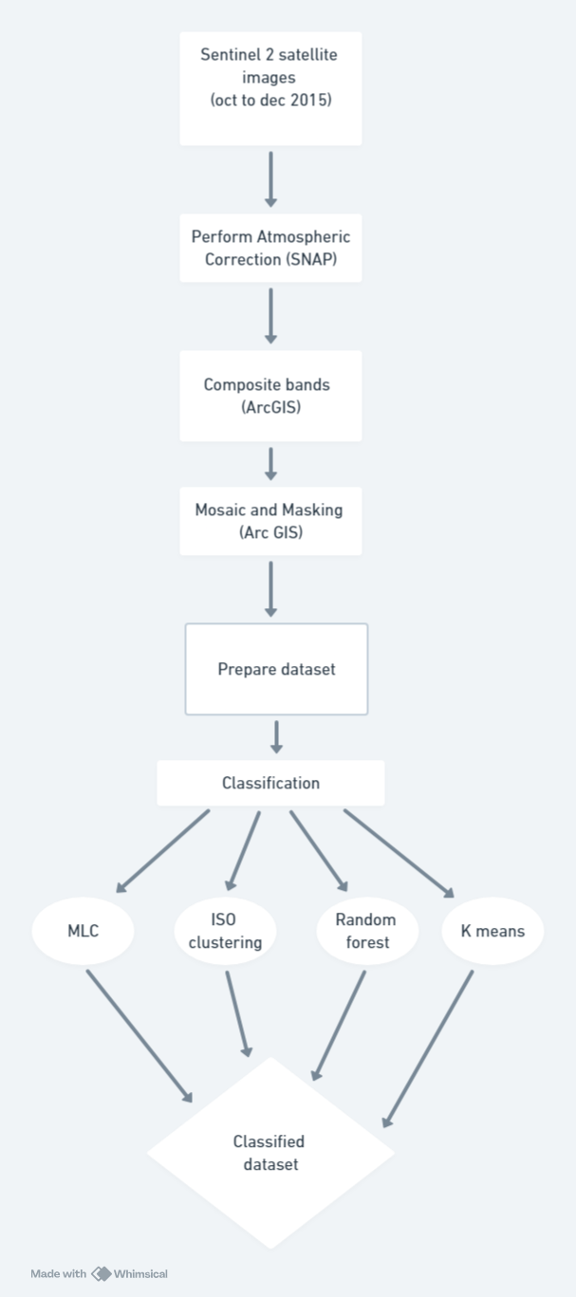

**SYSTEM ARCHITECTURE OVERVIEW**

The system architecture of the "Deforestation Mapping Using Satellite Images and Deep Learning Techniques" project involves several key modules tailored to process satellite imagery and perform deforestation analysis. Below is an overview of the modules used in this project:

1. **Satellite Image Acquisition Module**:
   * **Description**: Responsible for acquiring satellite images from various sources, such as Sentinel and Landsat, for the year 2015.
   * **Functionality**: Fetches multi-temporal satellite images capturing forested regions to analyze deforestation trends over time.
2. **Atmospheric Correction Module (Using SNAP)**:
   * **Description**: Utilizes the Sentinel Application Platform (SNAP) for atmospheric correction of the acquired satellite images from 2015.
   * **Functionality**: Corrects atmospheric distortions to enhance the quality of satellite images, ensuring accurate analysis results.
3. **Composite Band Generation Module (Using ArcGIS)**:
   * **Description**: Employed within ArcGIS to create composite bands from the preprocessed satellite images.
   * **Functionality**: Combines bands from different images to generate composite images, providing enhanced visualizations for analysis.
4. **Mosaicing and Masking Module (Using ArcGIS)**:
   * **Description**: Utilizes ArcGIS for mosaicing and masking operations on the composite satellite images.
   * **Functionality**: Mosaics multiple satellite images into a single image and masks out non-forested areas to focus the analysis on forest cover.
5. **Dataset Preparation Module**:
   * **Description**: Prepares the dataset for classification by extracting relevant features and labels from the mosaicked and masked satellite images.
   * **Functionality**: Converts the processed satellite images into a format suitable for supervised and unsupervised classification algorithms.
6. **Supervised and Unsupervised Classification Module**:
   * **Description**: Performs supervised and unsupervised classification on the prepared dataset using four algorithms: K-means, Maximum Likelihood Classification (MLC), Random Forest, and Iso Clustering.
   * **Functionality**: Classifies pixels within the satellite images into different land cover classes, including deforested and forested areas, based on spectral characteristics.
7. **Analysis Module**:
   * **Description**: Analysis the classified dataset generated for 2015 to analyze deforestation trends.
   * **Functionality**: Conducts a comparative analysis of deforestation patterns and changes between the two time periods, providing insights into the extent and drivers of deforestation.

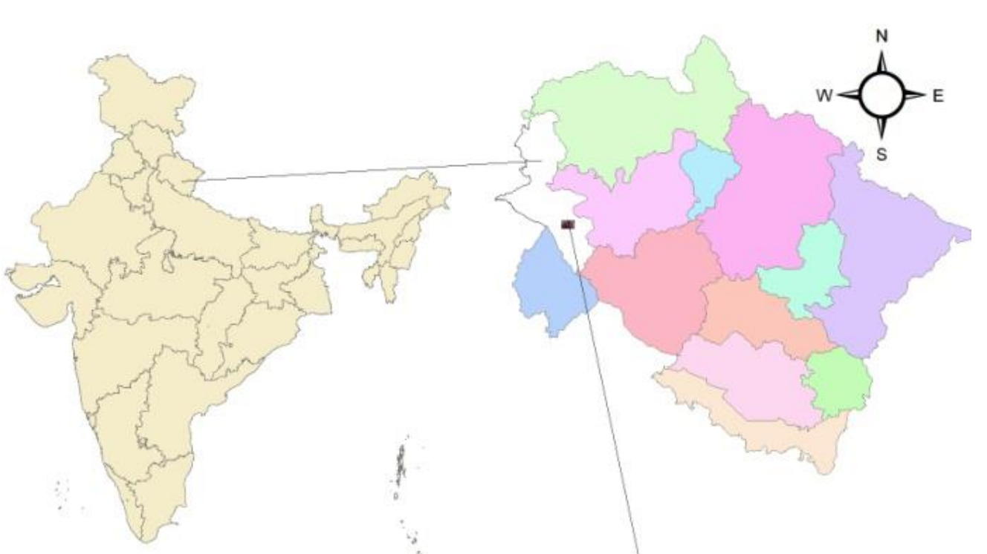

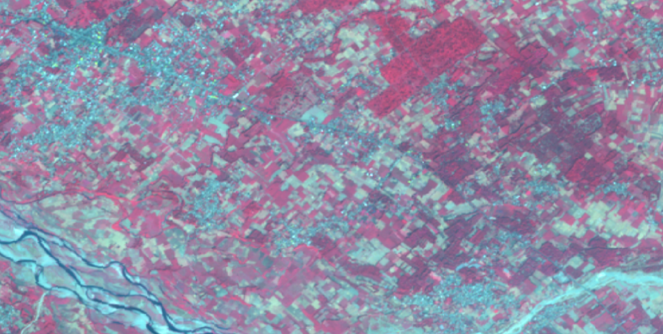

**SENTINEL 2 IMAGES**

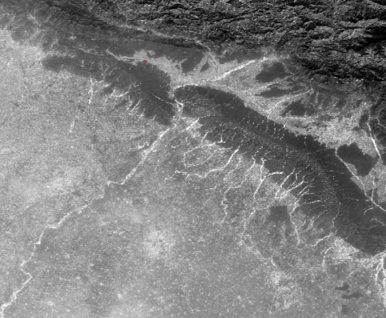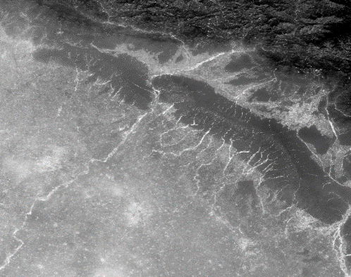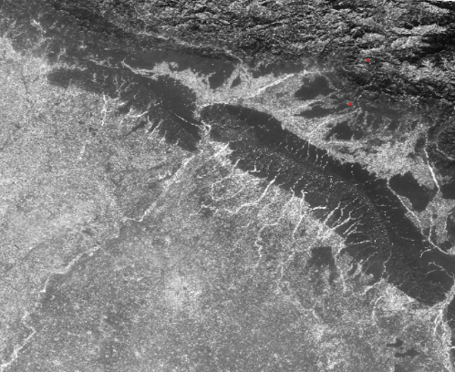

Band 2

Band 3

Band 4

Band 8

**Composition**

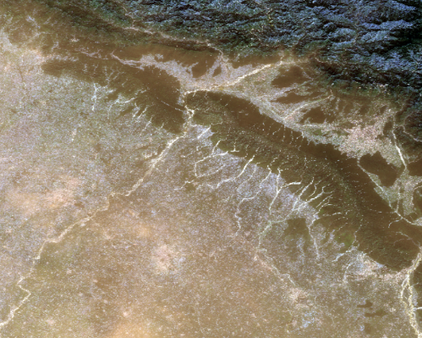

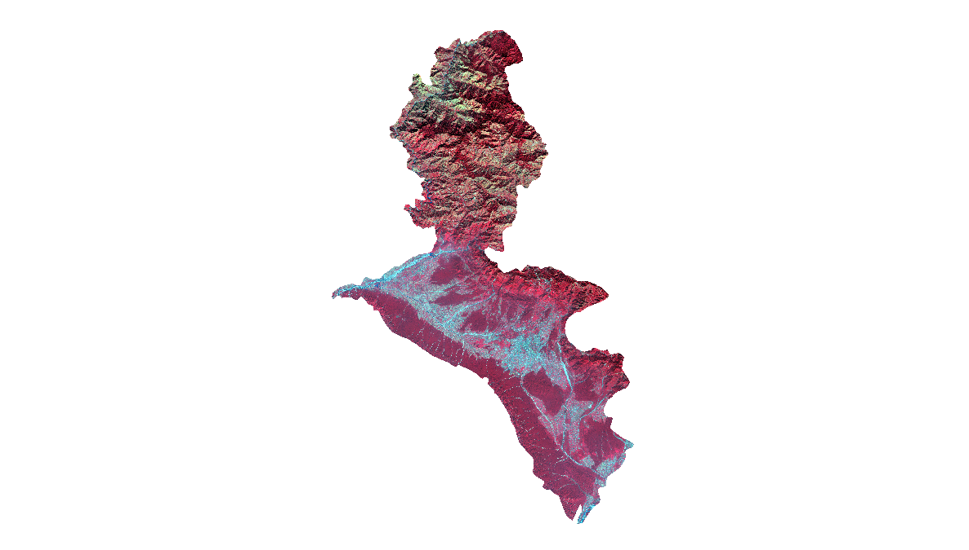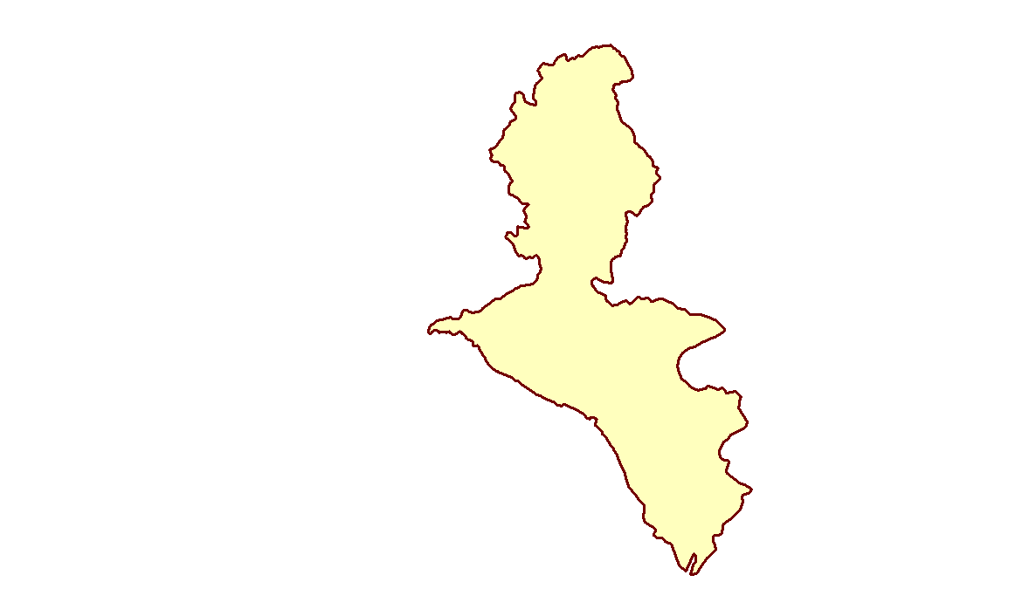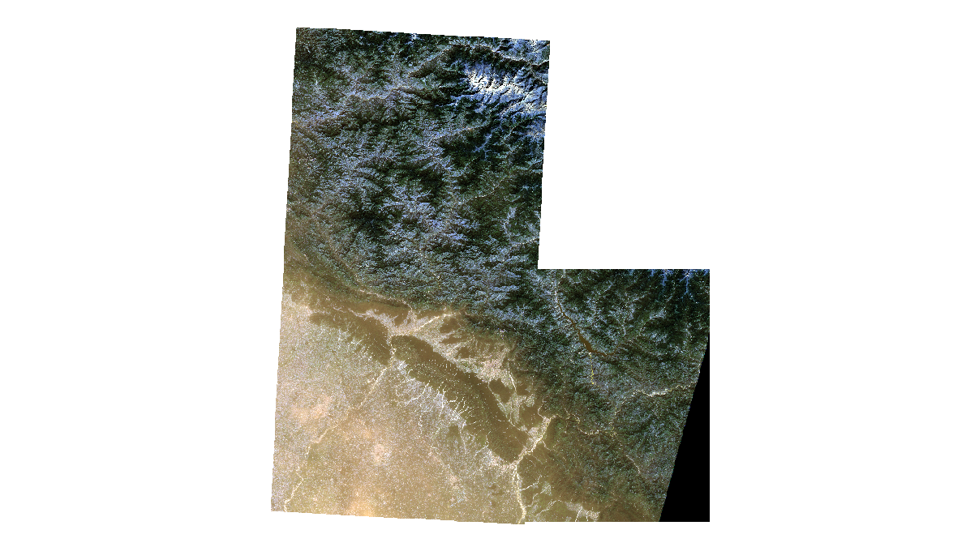

**Masking**

**Classification Results :**

The MLC, K-means, KNN, Random Forest algorithm was employed to classify the preprocessed and masked Sentinel-2 imagery. The training data, which included representative samples of each land cover type, facilitated the supervised classification process. The classification output was generated in the form of a raster image with each pixel assigned to one of the six land cover classes.

**Land Cover Classes**

* **Evergreen Forest:** Represents areas with dense, year-round foliage. These areas are critical for maintaining biodiversity and ecological balance.
* **Deciduous Forest:** Includes regions with trees that shed leaves seasonally. These forests play a vital role in carbon sequestration and habitat provision.
* **Cropland:** Denotes agricultural lands used for crop production. These areas are essential for food security and local economies.
* **Fallow Land:** Areas left uncultivated to restore soil fertility. This classification helps in understanding agricultural practices and land use changes.
* **Water Bodies:** Includes rivers, lakes, and reservoirs. These are vital for hydrological studies and water resource management.
* **Developed Area:** Represents urban and built-up regions. This classification is crucial for urban planning and infrastructure development.

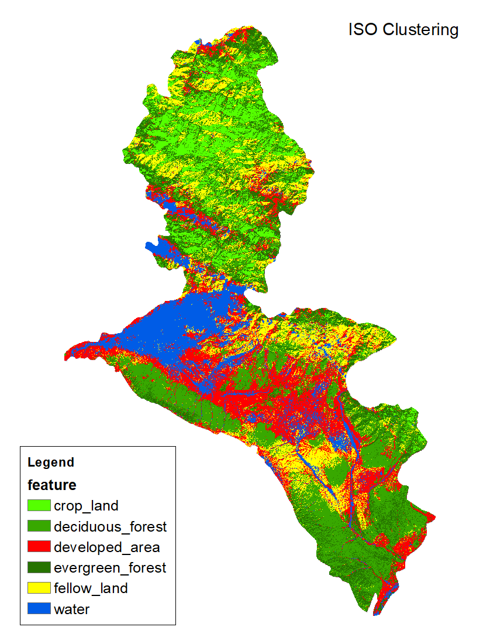

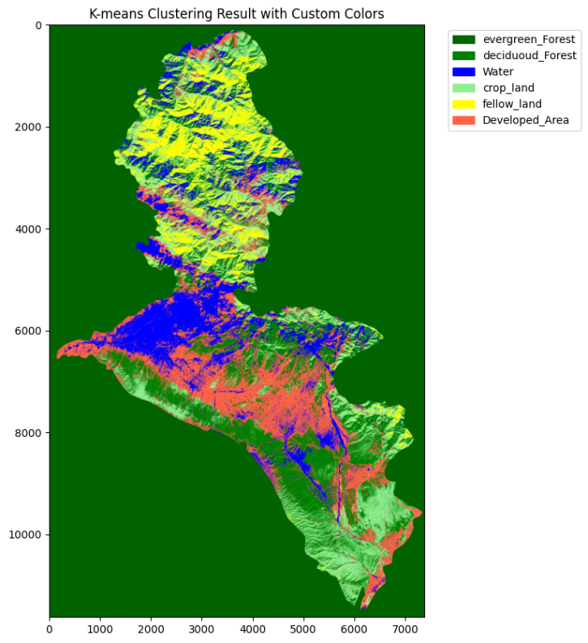

**Most Likelihood Classification**

* **Probabilistic Approach**: MLC calculates the probability that a pixel belongs to each class based on the statistical characteristics (mean and covariance) of training data. The pixel is assigned to the class with the highest probability.
* **Assumptions**: Assumes that the pixel values for each class follow a multivariate normal distribution. This means MLC works best when this assumption holds true.
* **Training Data**: Requires a set of representative training data for each land cover class. The quality and representativeness of the training data significantly influence the classification accuracy.
* **Output**: Produces a classified image where each pixel is assigned to one of the predefined classes. Additionally, it can provide a probability map indicating the confidence level of the classification.

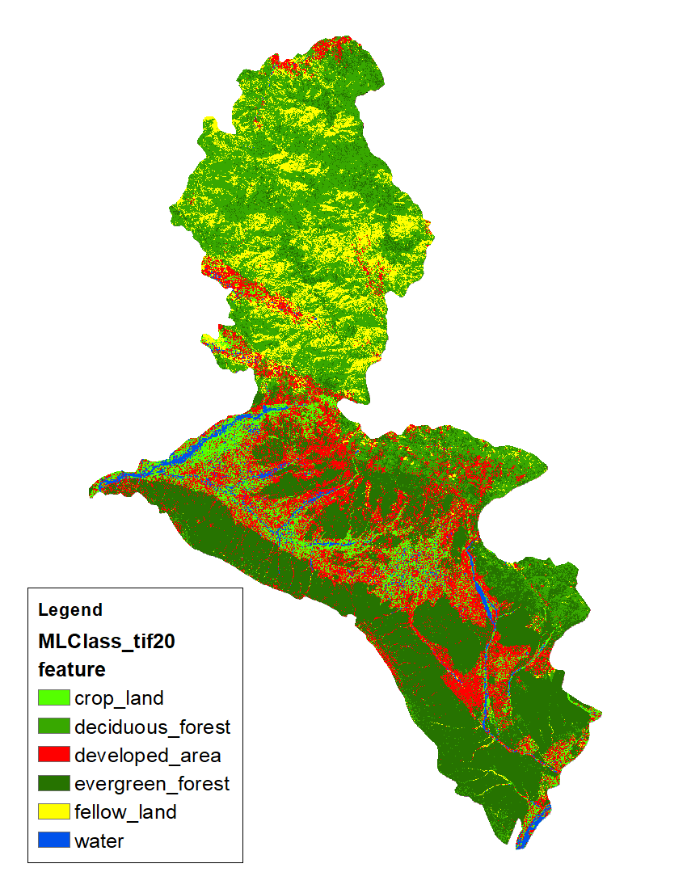

**Random Forest**

* **Ensemble Learning**:

Random Forest builds a 'forest' of many decision trees during training. Each tree is trained on a random subset of the data and a random subset of features.

* **Bootstrapping and Aggregation**:

Utilizes bootstrapping (random sampling with replacement) to create subsets of the training data. Aggregation of the results from multiple trees reduces overfitting and increases generalization.

* **Feature Importance**:

Can provide an estimate of feature importance, indicating which variables are most influential in the classification process.

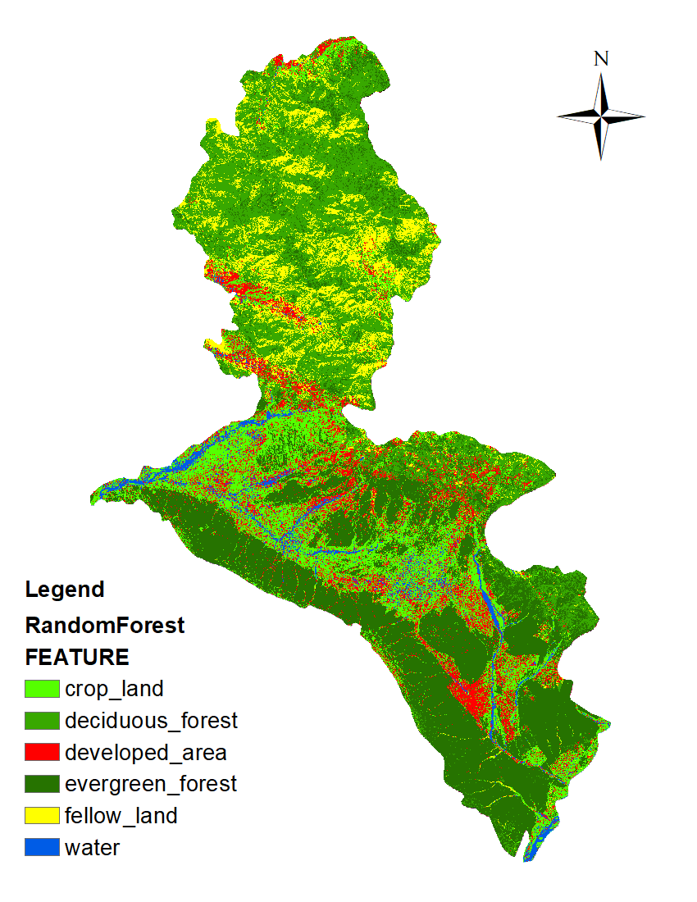

**FUTURE ENHANCEMENTS**

The deforestation mapping project in the Dehradun district has laid a strong foundation for ongoing monitoring and analysis of land cover changes. To build on the current achievements and address emerging challenges, several future enhancements are proposed. These enhancements aim to refine the methodology, extend the scope of analysis, and improve the accuracy and applicability of the results.

**1. Comparative Analysis with 2020 Data**

In future phases of the project, the same operations and methodologies applied to the 2015 data will be performed on Sentinel-2 satellite imagery from October to December 2020. This will enable a comprehensive comparative analysis to assess the extent of deforestation and other land cover changes over the five-year period. Key enhancements in this phase include:

* **Consistent Methodology**: Applying the same preprocessing, classification, and validation techniques to ensure comparability between the 2015 and 2020 datasets.
* **Change Detection**: Utilizing advanced change detection algorithms to quantify the specific areas and magnitudes of deforestation and land cover transformation.
* **Temporal Analysis**: Incorporating multi-temporal analysis techniques to understand the dynamics of land cover changes and identify patterns or trends over time.

**2. Integration of Additional Data Sources**

To enhance the accuracy and depth of analysis, future work will involve integrating additional data sources such as:

* **High-Resolution Imagery**: Incorporating high-resolution satellite imagery from sources like Landsat or commercial providers to complement Sentinel-2 data and improve the granularity of land cover classification.
* **Ground Truth Data**: Expanding the collection of ground truth data through field surveys and collaboration with local agencies to validate and refine classification results.
* **Environmental Variables**: Including environmental variables such as topography, climate data, and soil information to improve the robustness of classification models and better understand the drivers of deforestation.

**3. Advanced Classification Techniques**

Future enhancements will explore the use of more sophisticated machine learning and deep learning algorithms to improve classification accuracy and efficiency:

* **Deep Learning Models**: Implementing convolutional neural networks (CNNs) and other deep learning models that can capture complex patterns and relationships in the data, potentially leading to more accurate land cover classifications.
* **Hybrid Models**: Developing hybrid models that combine the strengths of different algorithms, such as integrating Random Forest with support vector machines (SVMs) or neural networks, to enhance classification performance.

**4. Automation and Scalability**

To streamline the workflow and make the process scalable to larger areas or different regions, the following enhancements are proposed:

* **Automation of Workflow**: Developing automated scripts and tools to handle repetitive tasks such as data downloading, preprocessing, and classification, reducing manual effort and the potential for errors.
* **Cloud Computing**: Leveraging cloud computing platforms for processing large datasets and running computationally intensive algorithms, enabling the analysis of extensive regions and multiple time periods efficiently.

**5. Stakeholder Collaboration and Application**

Future work will focus on enhancing the practical application and impact of the project by collaborating with various stakeholders:

* **Local Authorities**: Engaging with local government agencies and conservation organizations to apply the findings in policy-making, land management, and conservation planning.
* **Community Involvement**: Involving local communities in data collection and validation efforts, fostering community awareness and participation in forest conservation initiatives.
* **Educational Outreach**: Developing educational materials and workshops based on the project findings to inform and educate stakeholders about the importance of forest conservation and sustainable land use practices.

# EXPECTED OUTCOMES

**1. Enhanced Deforestation Monitoring:**

* **Feature**: Utilization of satellite imagery and deep learning algorithms.
* **Functionality**: Analyzes satellite images to detect and monitor deforestation activities over time.
* **Benefit**: Provides accurate and timely insights into deforestation trends, facilitating informed decision-making for conservation efforts and land management.

**2. Automated Deforestation Detection:**

* **Feature**: Deep learning-based deforestation detection models.
* **Functionality**: Automatically identifies deforested areas within satellite images using machine learning algorithms.
* **Benefit**: Enables efficient and objective assessment of deforestation, reducing the need for manual analysis and increasing scalability.

**4. High-Resolution Deforestation Mapping:**

* **Feature**: GIS-based mapping and visualization.
* **Functionality**: Generates high-resolution maps of deforested areas, providing detailed spatial representations of deforestation patterns.
* **Benefit**: Enhances visualization and spatial analysis, facilitating targeted conservation interventions and monitoring.

**5. User Awareness and Education:**

* **Feature:** Publicly accessible deforestation data and visualizations.
* **Functionality**: Generates reports and interactive maps that are easily understandable by the general public.
* **Benefit**: Raises awareness about the extent and impact of deforestation, promoting community engagement and support for conservation initiatives.

**6. Comprehensive Deforestation Mapping:**

* Feature: Detailed and accurate deforestation maps over a five-year period.
* Functionality: Utilizes satellite images to create high-resolution maps that display changes in forest cover, including developed areas, evergreen forests, and deciduous forests.
* Benefit: Provides clear visual evidence of deforestation trends, facilitating informed decision-making and targeted conservation efforts.

# CONCLUSION

The deforestation mapping project in the Dehradun district aimed to assess and quantify land cover changes over a five-year period (2015-2020) using advanced remote sensing and geospatial analysis techniques. By leveraging Sentinel-2 satellite imagery and state-of-the-art classification algorithms, this project has successfully provided detailed insights into the patterns and extent of deforestation within the region.

**Key Findings**

1. **Effective Classification**: The application of Maximum Likelihood Classification (MLC) and Random Forest algorithms facilitated accurate land cover classification. The integration of these techniques ensured robust identification of six key land cover classes: Evergreen Forest, Deciduous Forest, Cropland, Fallow Land, Water Bodies, and Developed Area.
2. **Data Comparison**: Comparative analysis between the classified maps of 2015 and 2020 revealed significant deforestation trends. The findings highlighted a reduction in forested areas, accompanied by an increase in developed and agricultural lands, underscoring the impact of urbanization and agricultural expansion on the region's forest cover.
3. **Accuracy and Validation**: The accuracy assessment of the classification outputs demonstrated high levels of precision, with overall accuracy exceeding 90% and a Kappa coefficient of 0.89. These metrics affirm the reliability of the classification results, providing a solid foundation for further environmental monitoring and decision-making.
4. **Methodological Framework**: The systematic methodology adopted in this project, encompassing data acquisition, preprocessing, classification, and validation, serves as a replicable framework for similar studies in other regions. The use of open-source tools and publicly available satellite data ensures the accessibility and scalability of the approach.

**Implications for Conservation and Policy**

The insights gained from this project have significant implications for forest conservation and land management policies in the Dehradun district. The observed deforestation trends call for urgent measures to mitigate forest loss and promote sustainable land use practices. Policymakers and conservationists can leverage the detailed maps and analysis to identify priority areas for intervention and develop targeted strategies to preserve the region's ecological balance.

**Future Work**

This project sets the stage for ongoing monitoring and research. Future work will involve:

* Extending the analysis to more recent satellite data to track ongoing changes and refine deforestation trends.
* Integrating additional environmental variables and ground truth data to enhance classification accuracy and robustness.
* Collaborating with local authorities and conservation organizations to implement data-driven conservation strategies and monitor their effectiveness.

**Final Thoughts**

In conclusion, this deforestation mapping project has successfully demonstrated the power of remote sensing and machine learning in environmental monitoring. By providing a comprehensive and accurate assessment of land cover changes in the Dehradun district, the project contributes valuable knowledge to the field of environmental science and supports efforts to preserve the region's natural resources. The methodologies and findings presented herein not only advance scientific understanding but also pave the way for informed conservation actions and sustainable development.

**REFERENCES**

* 1. Authors R Saini, Sanjay Kumar Ghosh Publication date 2018/11/19 Journal The International Archives of the Photogrammetry, Remote Sensing and Spatial Information Sciences Volume 42 Pages 683-688 Publisher Copernicus GmbH. [isprs-archives-XLII-5-683-2018.pdf (copernicus.org)](https://isprs-archives.copernicus.org/articles/XLII-5/683/2018/isprs-archives-XLII-5-683-2018.pdf)
  2. Authors Rashmi Saini, Sanjay Kumar Ghosh Publication date 2019/12 Journal Geocarto International Pages 1-19 Publisher Taylor and francis [link](https://scholar.google.co.in/citations?view_op=view_citation&hl=en&user=iPefWC8AAAAJ&citation_for_view=iPefWC8AAAAJ:Y0pCki6q_DkC)
  3. Authors R Saini, Sanjay Kumar Ghosh Publication date 2018/4/30 Journal The International Archives of the Photogrammetry, Remote Sensing and Spatial Information Sciences Volume 42 Pages 1499-1502 Publisher Copernicus GmbH https://[www.mdpi.com/2072-](http://www.mdpi.com/2072-) 4292/9/11/1137
  4. Castelluccio, M., Poggi, G., Sansone, C., & Verdoliva, L. (2015). Land use classification in remote sensing images by convolutional neural networks. In 2015 IEEE international geoscience and remote sensing symposium (pp. 2565-2568). IEEE. https://ieeexplore.ieee.org/document/7326343